**Licensing Guarantees:** The New Currency to Guarantee the Delivery of Network Ratings

# Overview

**Goal:** The objective is to provide content owners a ‘metric’ or ‘new currency’ to guarantee programming performance when licensing content to networks. (Please Note: This applies for both New Releases & Library Content).

**Business Background:** A typical syndication deal outlines a set of assets that a Cable & Broadcast can air for a restricted period of time and a limited number of exhibitions. With no way to determine the perceived value of each title and justify the license fee per title, Cable & Broadcast Networks find themselves flying blind when quantifying the ROI of each acquisition.

By providing a metric to forecast the expected performance of each title and/or content bundle, networks can quantify the ROI of each acquired title, as well as, begin to buy content that best caters to their audience. Studios can in turn maximize the value of their content offerings.

**Approach:** This analysis requires a two step process:

1. Develop a similarity index across content library
2. Develop an advanced predictive model to forecast the following metrics:
   1. Ratings (National, Coverage, C3 etc…)
      1. By Daypart
      2. By Demo
   2. Average Audience
      1. By Demo
   3. Reach
      1. By Demo

**Key Datasets to Leverage:**

* Nielsen MIT: Ratings information across Video Streams (Live, Live +SD, Live +7)
* Nielsen Dailies: Live +3 Viewership
* Nielsen NAD: Audience Composition by Market Breaks
* Nielsen AMRLD: All minute respondent level data for viewer demographic and behavioral insights
* Respondent level data across linear and non-linear platforms
* Programming Metadata via IMDB

# Business Background

The content supply chain is a pretty standard process that has withstood the test of time. Even with the introduction of ‘DVDs’ and ‘Video On Demand’, movie studios know exactly who to sell their content to within each window.

Most importantly, movie studios have an endless supply of content to sell. New movie releases following the On Demand Windowing Path that is illustrated below.

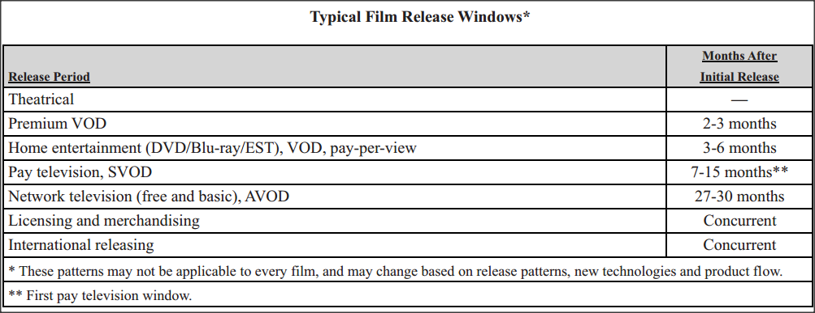

figure 1 – theatrical windowing breakdown

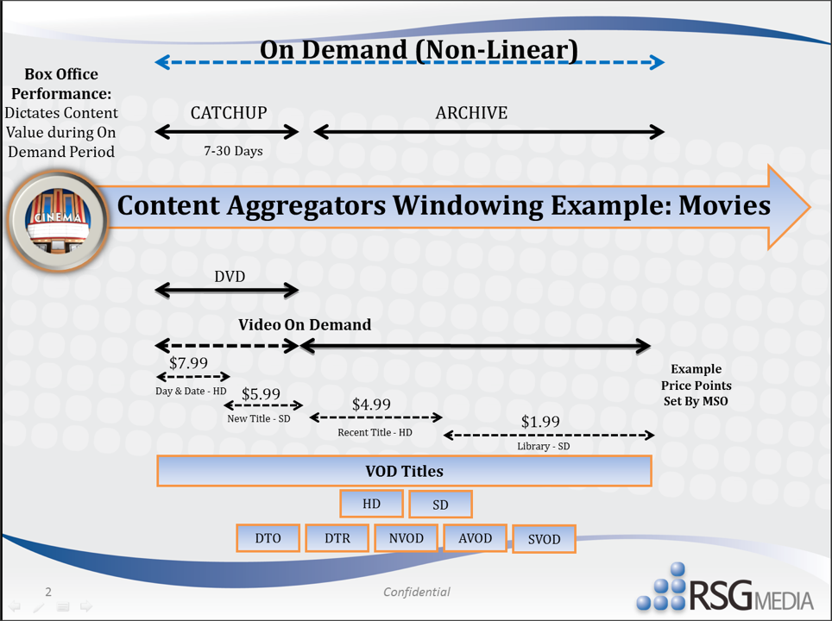

figure 2 – on demand (tvod) windowing breakdown

Library titles (old movies) are always bought in the syndication window (For example new movies like the dark knight geso to TNT/TBS only after it goes to iTunes/Amazon, HBO (pay cable) then cable networks (i.e TNT/TBS) then broadcasters…

So long story short cable and broadcast networks are always being movies that are old. When Cable networks buy movies (for example when Univision buys movies to air) they know each and every movie available to purchase is old. The Cable Network has no idea on how the movie will perform, at the end of the day they have to fill up their schedules 24/7… they need content to air…

# The Business Opportunity

Movie studios have an interesting opportunity to create a metric ‘new currency’ when selling movies to cable and broadcast networks. By guaranteeing a minimum ‘rating’, networks have an idea on the ROI of the purchase of that movie (especially when the movie studio is placing a restriction on how many the network can air the movie and between what specific time rang ‘exhibition window’).

With the ability to create rating guarantees, movie studios have the ability to mark up the value of their content based on the forecasted performance (ratings/viewership aka ad dollars) of each movie. The makes for a competitive market place of buyers, who will be bidding for movies to make sure they can get the best movie at the right price that is the right fit for their viewers.

# The Approach

1. Understand each networks audience demographic
   1. This way we can understand viewers taste/preference
2. Determine how ‘measure’ the similarities of like movies
3. Using historical performance of ‘like’ content, we can forecast the expected ratings delivered for their network (down to a given daypart)

**Question 1:** How to measure the ‘similarities’ in movies

Nanogenres… Heatmap used to identify exact correlation between programming -> Shiv to speak to Rod

